Computer aided diagnostic for lung diseases: Covid-19, Pneumonia, Tuberculosis using deep learning
Daouda Sele DIEYE and Pape Adama Mboup
¹ Princeton University, Princeton NJ 08544, USA
² Springer Heidelberg, Tiergartenstr. 17, 69121 Heidelberg, Germany
lncs@springer.com
Abstract. A respiratory disease is a disease that affects the respiratory system or causes trouble breathing. Many types of lung diseases such as tuberculosis, covid-19 and pneumonia can causes chronic respiratory conditions. Chronic respiratory disease affects and kills millions of people in the World[1].Chest X-ray (CXR) is a rapid imaging technique that allows lung abnormalities to be identified. CXR is used to diagnose conditions of the thoracic cavity, including the airways, ribs, lungs, heart and diaphragm, but despite its low specificity and difficult interpretation, it’s one of the preferred methods for screening these diseases [2].This article presents the prediction of Covid-19, Pneumonia and Tuberculosis with chest x-ray images with an approach based on deep learning and convolutional neural networks to predict sick and normal patients, thereby helping doctors and medical staff to make a quick and informed decision about the presence of disease. Deep learning tools such as TensorFlow and Keras were used with various functions, such as Conv2D, Maxpooling2D, and Dense Net to create the model. The proposed approach has a classification accuracy of 80% on X-ray image tests.

Keywords: Chest X-ray, Covid-19,Tuberculosis,Pneumonia, Convolutional Neural network,
- Introduction
In recent times, Coronavirus disease has become the biggest health hazard worldwide.
The coronavirus disease 2019 (COVID-19) pandemic was caused by severe acute respiratory syndrome coronavirus 2 (SARS-CoV-2). The consequences of this pandemic have caused threats to life among the human race. Although mild and moderately affected COVID-19 patients recovered quickly without any special treatment, numerous studies have confirmed that older people are vulnerable to the severe effects of this disease, particularly those with preexisting medical conditions such as cardiovascular disease, diabetes, chronic respiratory disease, and cancer[3]. About 15% of COVID-19 cases are severe. That means they may need to be treated with oxygen in a hospital. About 5% of people have critical infections and need a ventilator.As of February 2022, the pandemic had caused more than 401 million cases and 5.76 million deaths, making it one of the deadliest in history[4].
Pneumonia is an acute pulmonary infection that can be caused by bacteria, viruses, or fungi and infects the lungs, causing inflammation of the air sacs and pleural effusion, a condition in which the lung is filled with fluid. It accounts for more than 15% of deaths in children under the age of five years [5].
Tuberculosis is an infectious disease caused by the bacterium Mycobacterium tuberculosis, which is transmitted through the air, with variable clinical signs. It most often affects the lungs and can sometimes affect other organs. The World Health Organization estimates that each year approximately 8 million people develop pulmonary tuberculosis worldwide and nearly 2 million people die from the disease [6].
Deep learning because of its versatility, its high performance, its great capacity for generalization and its multidisciplinary uses and many other qualities. Moreover, with a large amount of medical data and the development of more powerful computers, there has also been an interest in this field. In the context of deep learning, a convolutional neural network (CNN) recently shed light in computer vision for both supervised and unsupervised learning tasks has shown peak performance in tasks ranging from classification of breast cancer, from organ and tumor segmentation to scan time reduction for diffusion MRI, to name a few [7].For the diagnosis, deep convolutional networks have demonstrated performance at least equivalent to that of the best competing approaches, while being conceptually simpler [8]. In this work, we address these questions. We present a deep learning architecture suitable for the diagnosis of lung diseases. The precision obtained from the CNN model is 80%. In this way, it can be said that classification using X-ray images, such as a chest X-ray (CXR), can be accurate in reducing the prevalence of the disease.
For the diagnosis of tuberculosis, deep convolutional networks have demonstrated performance at least equivalent to that of the best competing approaches, while being conceptually simpler [8]. In this work, we address these questions. We present a deep learning architecture suitable for the diagnosis of tuberculosis. The precision obtained from the CNN model is 80 %. In this way, it can be said that classification using X-ray images, such as a chest X-ray (CXR), can be accurate in reducing the prevalence of the disease.

- Materials and methods
A The proposed system aims to predict Normal, Covid-19, Pneumonia and Tuberculosis from chest X-ray images using deep learning and convolutional neural networks. The available dataset [9] was collected from Kaggle, which relates to Normal and Covid-19, Pneumonia, and TB chest X-ray images. The dataset contains 7135 image samples.

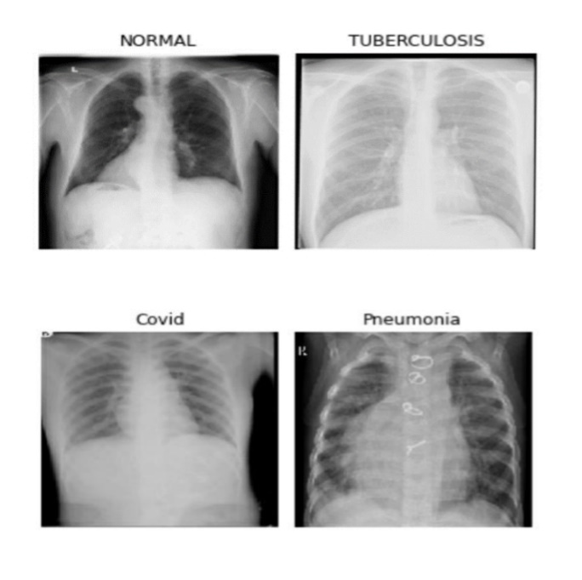

Fig. 1 Chest X-ray of Normal,Tuberculosis, Covid,Pneumonia patient

For training, 88% of the images were assigned, 2% for validation, and the remaining 10% were used for testing. Data augmentation was performed with resize and image flips.
All input images are scaled to 250*250, thus chest X-ray images are labeled with "0" for Covid positive, "1" for Normal, "2" for Pneumonia and "3" for Tuberculosis. Then, we successively added 3 layers of convolutions of 32 filters and 2 of 64 filters of sizes 3x3 with maximum pooling for the dimensionality reduction of the previous layer. The images are then flattened into two fully connected neural network layers with dropout regularization technique where randomly selected neurons are ignored during training that reduce overfitting. It receives a single vector as input; an output layer will classify the image. Nonlinearity is induced in the CNN by the sigmoid activation function. The model's learning rate has been lowered to 0.00001 and the chosen optimizer is Adam. The number of epochs is specified at 10 with an early stop implemented to halt training if model improvement is stopped.
The CNN models were executed on Windows 8.1operating system, with 500 GB hard disk, 8GB RAM and no GPU support. Keras API was used to build the models with TensorFlow backend. Python programming language, implemented in Jupyter notebook. The architecture of the model can be visualized, using the summary function in Keras (figure 2).

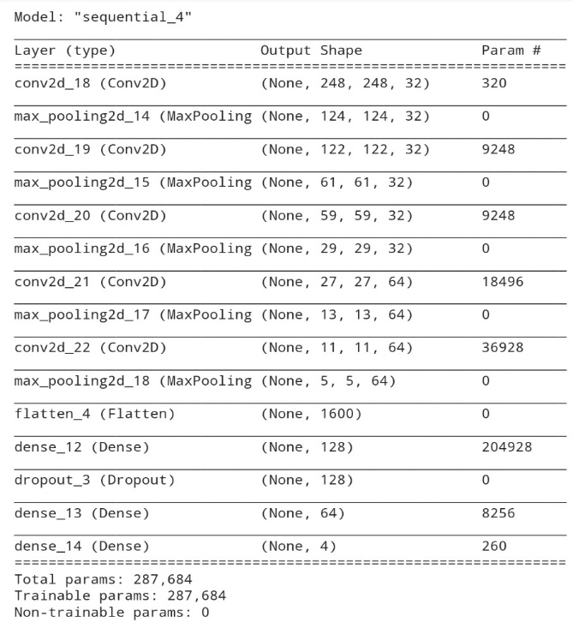
Fig. 2. Architecture of the neural network used for learning.

- Results and Discussion
a In this section, we report the results of the evaluation of the proposed method on the two chest x-ray sets, four standard evaluation measures were used: accuracy, precision, recall and the f1-score.
To define these evaluation measures, we first define the terms "true positive", "false positive", "true negative", and "false negative". In a binary classification task, suppose the two classes in the dataset are called the "positive" class and the "negative" class. The above terms can then be defined as follows:
• True positive (TP) refers to a sample belonging to the positive class, correctly classified by a model.
• False Positive (FP) refers to a sample belonging to the negative class, being incorrectly classified as belonging to the positive class.
• True Negative (TN) refers to a sample belonging to the class negative, correctly classified by the model.
• False Negative (FN) refers to a sample belonging to the positive class, being incorrectly classified as belonging to the negative class.

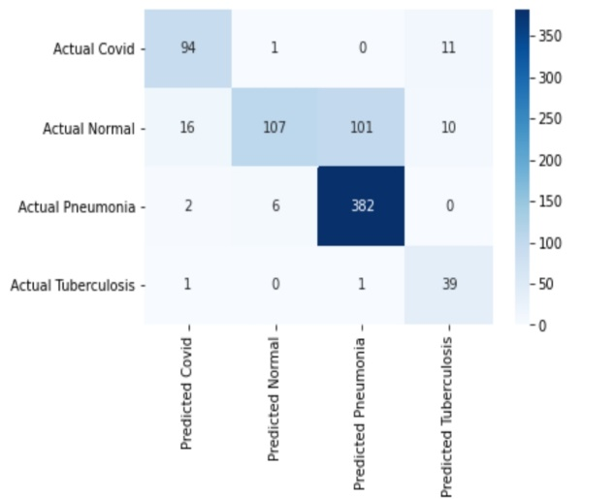
Fig. 3. Model confusion matrix:

Now the four evaluation metrics can be defined as:
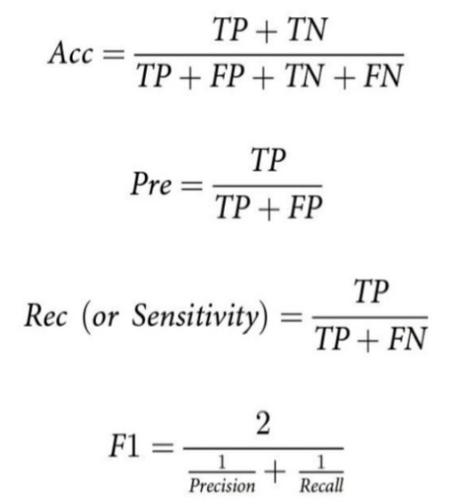
The accuracy rate provides an overall measure of the number of correct model predictions. However, a high accuracy rate of a model does not guarantee its ability to distinguish between different classes equally if the dataset is unbalanced.
In particular, in medical image classification, a generalizable model to all classes is necessary. In such cases, the "precision" and "recall" values provide insight into the performance of the model. Precision indicates the accuracy of the model's positive label prediction. This provides the ratio of correct predictions to the total predictions produced by the model. Conversely, “recall” measures the percentage of true positives that the model correctly predicted. These two evaluation measures assess whether the model can reduce the number of FP and FN predictions. "F1-Score" provides a balance between "accuracy" and "recall", taking into account both FP and FN. It penalizes the extreme values ​​of “precision” and “recall”, each of which is reached to the detriment of the other. The results obtained are shown in (Table 1)

 | precision | recall | f1-score
Covid | 0.83 | 0.89 | 0.86
NORMAL | 0.94 | 0.46 | 0.61
Pneumonia | 0.79 | 0.98 | 0.87
TUBERCULOSIS | 0.65 | 0.95 | 0.77

Table 1. Model evaluation metrics

Thus, in the classification of medical images, it is useful to consider evaluation metrics rather than only the accuracy rate to obtain an accurate identification of a non-ill person, as well as a sick person. The learning and validation curves can be represented using the two graphs below.
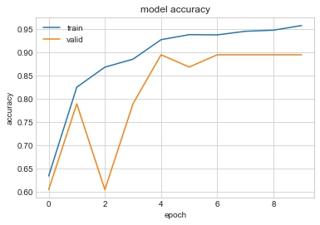
Fig 4. Training and validation accuracy

Fig 5. Training and validation loss

(Figure 4) shows at the beginning that the training accuracy and validation is Increasing. At epoch 2, there is a small increase in training accuracy and a decrease for validation. Epoch 3 has medium training growth and a rapid growth for validation. After the third epoch we have a continiuous growth for the training accuracy, for the validation we have rapid growth with a little decrease at epoch 5. At the last epoch the highest training accuracy is 94.75% and 89.47% for validation.
On the other hand (figure 5), the loss chart shows a decline for the train and the validation loss. Here, the highest training loss is close to 0.94% and 0.82% for the validation at epoch 0. When the epoch is between 0 and 6, we have a sawtooth validation decay, the validation loss decreases again with a slight increase at epoch 9 and around 0.29. The training loss is at 0.1 %.
A chest x-ray image can be scanned and entered into the program and correctly predict chest x-ray images with a high probability of success.

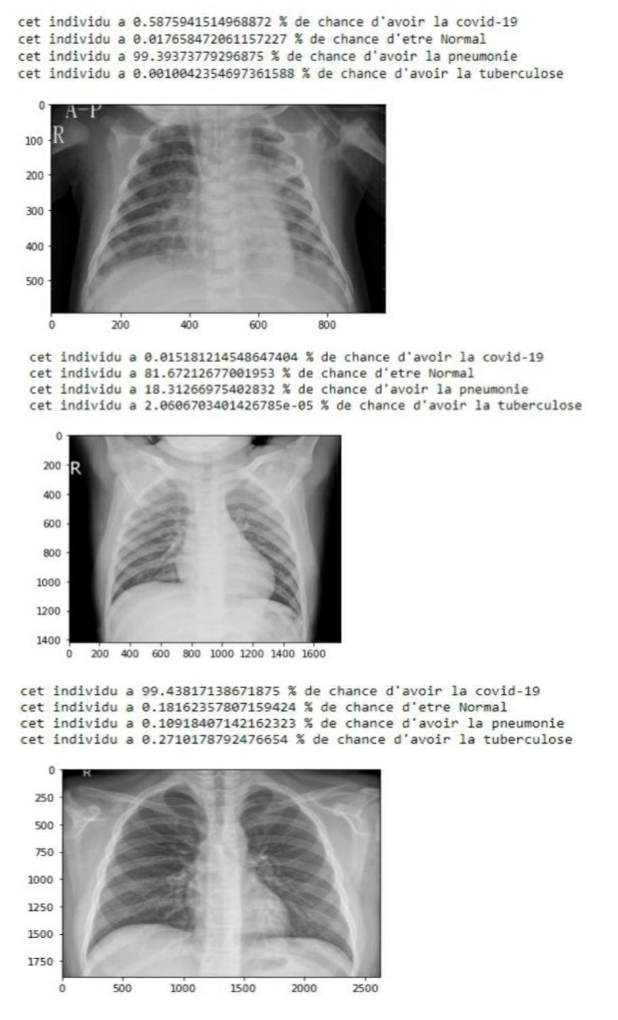

Fig 6. Browsed chest X-ray image fed into the program to detect diseases probabilities

To have a better accuracy rate, we could have obtained a lot more data or used other neural network architectures such as Resnet50 or vgg-16 to do transfer learning, but that would require more computing time and ressources.
- Conclusion
Respiratory diseases are an enormous challenge to life, health and productive human activity. Despite progress in understanding the pathological mechanisms involved in each of these disorders, there is still no effective therapy able to halt their natural history or reverse the morphological and functional injury already established. Prevention, control and cure of these diseases and promotion of respiratory health must be a top priority in global decision making in the health sector. The control, prevention and cure of respiratory diseases are among the most cost-effective health interventions available. This article explains how with deep learning using neural networks and artificial intelligence. One can know its results as soon as possible and at low cost. In this detection model, we see that the accuracy of giving the true result is 80%. It means in 10 results, and there could be 2 false results. Open points that need to be addressed in future work include the use of pre-training and bigger datasets to bring the classification accuracy using more efficient neural network architecture generalize our model to other lung disease, Also, we can have the possibility to scale up the web application by helping users to save their login info, data and open their comment sections for better improvement, it could even be possible to generate a textual annotation for each case.

References
- https://www.physio-pedia.com/Respiratory_Disorders
- Van’t Hoog, A. H. et al. High sensitivity of chest radiograph reading by clinical officers. Int. J. Tuberc. Lung Dis. 15, 1308–1314 (2011). 3. Melendez, J. et al. An automated tuberculosis screening strategy combining X-ray-based computer-aided detection and clinical information. Sci. Rep. 6, 1–8 (2016).
- https://en.m.wikipedia.org/wiki/COVID-19
- https://covid19.who.int/
- WHO Pneumonia.WorldHealthOrganization. (2019), https://www.who.int/news-room/fact-sheets/ detail/pneumonia
- httpsa://en.m.wikipedia.org/wiki/Tuberculosis
- Litjens, G. et al. A Survey on Deep Learning in Medical Image Analysis. https://doi.org/10.1016/j.media.2017.07.005 (2017).
- Shin, H. et al. Learning to Read Chest X-Rays: Recurrent Neural Cascade Model for Automated Image Annotation. IEEE Conference on Computer Vision and Pattern Recognition (CVPR), pp. 2497–2506 (2016).
- https://www.kaggle.com/jtiptj/chest-xray-pneumoniacovid19tuberculosis

